**Meeting on Reviewing on Data import, Indicator, Report and Dashboard in MPI**

25-28 October 2022

The National Center for HIV/AIDS, Dermatology and STD (NCHADS) with financial support for US-CDC and technical support from EpiC-FHI360 is conducting Reviewing on Data import, Indicator, Report and Dashboard in MPI (Master Patient Index).

This meeting is conducted in Preah Sihanouk province for full 4 days with the general purpose of speeding up the process of developing MPI system. The specific objectives of this meeting are to map variables between legacy databases and MPI, assure all data was imported accurately from legacy databases to MPI, clarify on indicators, report, and dashboard in MPI, and Discuss on data quality check tools for MPI.

The participants of this meeting are only the technical team from local including NCHADS-DMU, US-CDC and EpiC-FHI360 as well as HISP-VN.

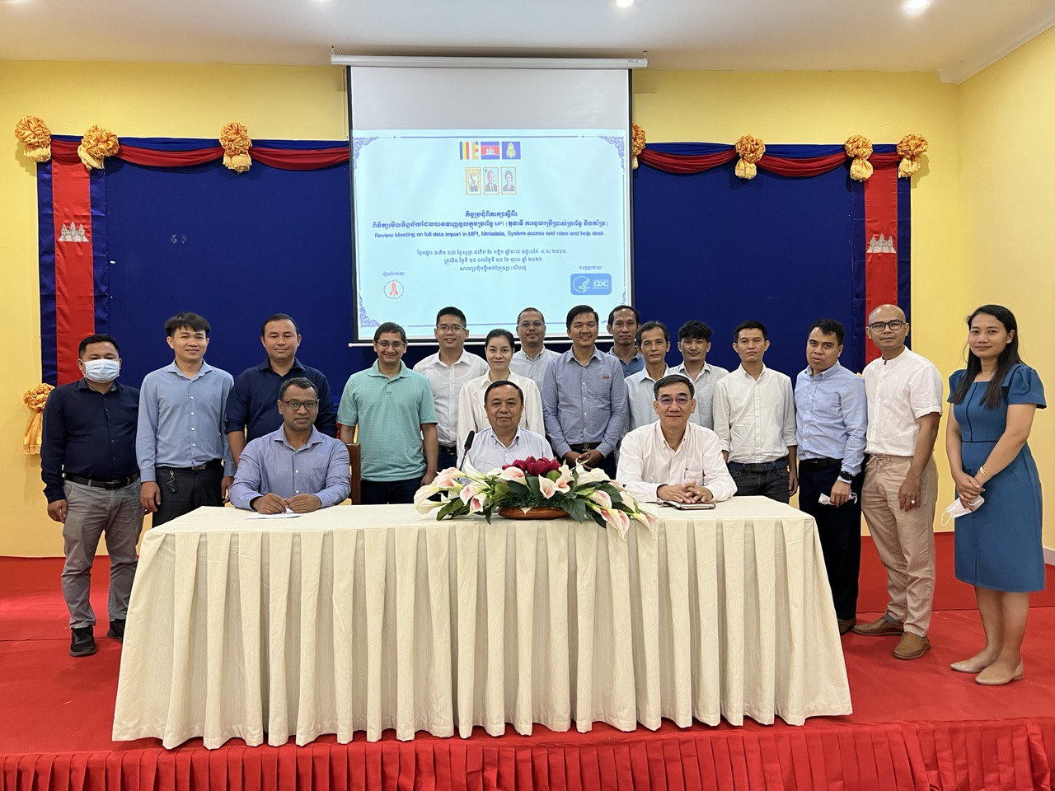

This event is starting from introduction of Mr. John Lewis, Lead of HISP-VN, informative remark from Dr. Ly Vanthy, Deputy Directors of US-CDC Cambodia, the important speech and opening by Dr. Kaoeun Chettra, Vice-chief of Technical Bureau and representative from NCHADS.

With the commitment of participation from all technical persons, the meeting will be fulfilled with fruitful discussion and hope to reach or go beyond the expected output.